 |  | Business Requirements Document
 |  | ESP KPI Tracker
Requested by: | Shane Wolf |  | Version: | 1.0
Prepared by: | Randy Schafer / Wayne Green |  | Date Prepared: | Sep. 23, 2021
Project Sponsor: | Derek Sztym |  | Date Requested:
Business Approver: | Travis Swallow |  | Date Approved:
Priority: | Medium
Table of Contents
1. Business Need 2
2. As-Is Situation 2
3. Proposed To-Be Process 3
4. Service Support and Service Delivery 3
5. Stakeholders 4
6. Conceptual Data Model 5
7. Functional Requirements – Presentation and Business Services 6
8. Non-Functional Requirements 7
9. Approvals 9
10. Document Revision History 9
11. Appendix A – Use Case Dialogs Template 10
12. Appendix B – Service Specifications 12

Business Need

Business Problem/Opportunity
In the last 4 years, CNRL has spent more than $174 million on Electric Submersible Pump (ESP) replacement and workovers. CNRLs ESP committee has done an amazing job eliminating waist, improving runtime, and reducing costs however the low hanging fruit gone. If we want to continue reducing our total cost of ownership, we need to leverage our large collection of performance and repair data to identify future failures before they happen.

Currently CNRL (Thermal and Conventional) uses a large cumbersome Excel workbook to track ESP reliability, cost, root cause analysis, KPI reporting, and live pump performance. The database has over 1,800 periods (installs, failures, and pulls) that date as far back as 1992. This tool is used by six different districts, and there is no easy way to combine post mortem failure details or lessons learned throughout the company. Excel limits how data can be gathered and what quality control can be applied. A large amount of time is being spent to manually enter data, find errors, and generate findings.

Desired Outcome
A dedicated ESP tracker would improve data quality and availability while freeing up subject matter experts to focus on analysis rather than data management.
ESP vendors would be able to submit information to be uploaded into the database rather than use manual entry.
More time is available for data analysis and proactive maintenance rather than reacting to failures. The desired outcome is a noticeable reduction in the number of pump failures.

As-Is Situation
All information related to ESP installation, failures, and repairs is currently kept in two very large Excel spreadsheets which each have more than twenty worksheets. There is data trending back to 2012 in these files.
The configuration of the spreadsheets and the loading of all pump related repairs falls to a small group of people. The data loading is all manual which introduces a number of errors which must be corrected manually.
Access to ESP detailed information is limited to those who can access the spreadsheets.
An overview of the ESP related processes is provided in Figure 1.

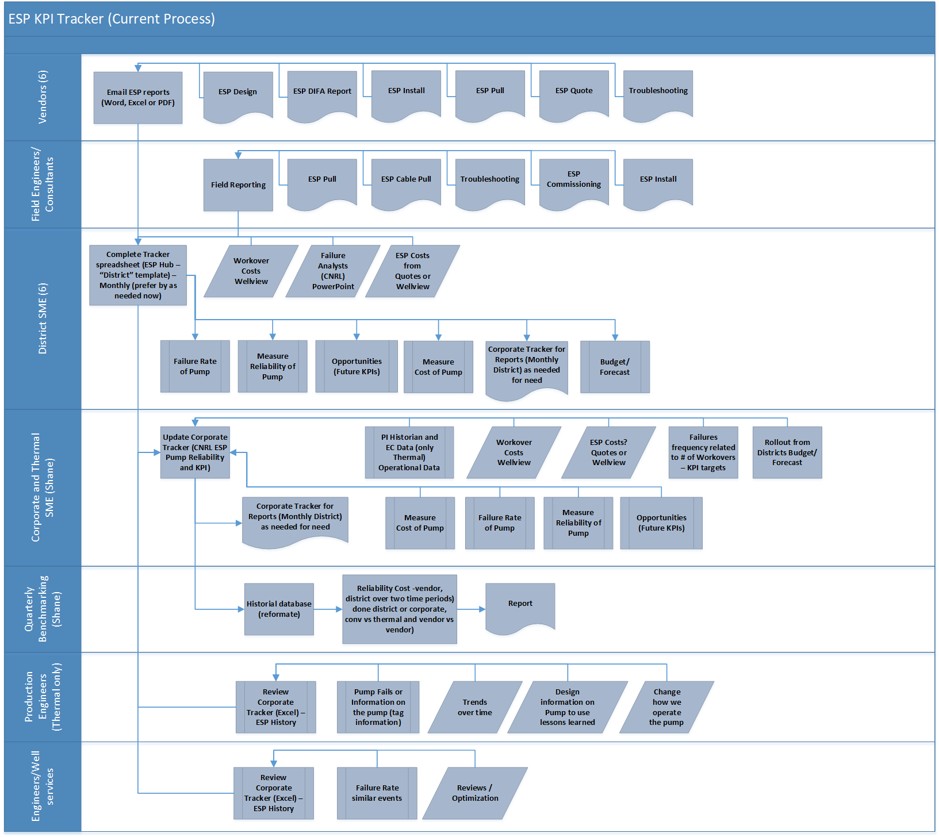
Figure 1: ESP Business Processes

Proposed To-Be Process
After the ESP KPI Tracker system is delivered, internal business procedures won't alter.
How data is obtained, kept, and managed will change. This will have an effect on how ESP vendors deliver data to us.
The creation of ESP analytics will be simpler because to the more reliable database's capability for an automated collection and loading operation.

Service Support and Service Delivery

Service Support
Information Systems offers two levels of support coverage:
- Standard Support – Support provided during business hours (i.e., Monday to Friday 8:00am to 5:00pm, excluding Statutory Holidays and Office Closures in Calgary; Monday to Friday 8:30am to 5:30pm, excluding Statutory Holidays and Office Closures in UK) in the time zone in which the responsible IS Support Team resides (e.g., desktop systems like PCs, VPCs, single user problems, etc.)

- Extended Support – Standard support during business hours; support available to address critical issues on an “on-call” basis outside business hours (e.g., infrastructure systems like network, storage, server, etc.)
Note: Support coverage does not imply a committed service level to resolve issues. Resolution timeframe will depend on the nature of the issue and resources required to resolve it.

Service Delivery
The Information Technology (IT) Service Continuity Plan (IS-STD-0084) describes the process and priorities for restoring computing resources deemed critical to the company, to an acceptable level of service in the event of a disaster. In the event of a disaster, infrastructure servers and associated services must restored first. Once this is complete, critical business applications will be restored on a priority basis.

Support Level | Disaster Recovery Priority
Standard | Best Effort

Stakeholders

Role/Name | # of People | Influence  Level | Interest  Level | Description
Shane Wolf | 1 | High | High | ESP SME / Administrator
Derek Sztym | 1 | High | High | Production Manager Kirby
Travis Swallow | 23 | High | High | VP Thermal Production
ESP Vendors | 6 | Low | High | 6 companies
District SMEs | 6 | Medium | High

Conceptual Data Model

Entity Name | Definition
Pump | All parameters associated with a particular pump
Repair | All details related to the repair of a particular pump
Vendor | All details related to a company carrying out pump repairs
Well | All details related to the location of a pump
User | Sets the access level which defines actions that can be taken

Functional Requirements – Presentation and Business Services

Use Cases
Use cases describe how people interact with the system to obtain a service.

Actor Name or Title | Description
Viewer | A viewer of reports and analytics
SME | A person who can manually update records
Vendor | An entity that submits pump repair reports
Administrator | Sets access levels

The table below documents the required system interactions.

Use Case # | Use Case Title | Use Case Description | Priority (MoSCoW) | Complexity
1 | User logs in | A user logs into the program or connects to a data view | Must | Low
2 | Vendor submits Repair | A standard form is completed and deposited in a location which allows for automated collection and addition to the database | Must | Med
3 | SME submits Repair | A standard form is completed and deposited in a location which allows for automated collection and addition to the database | Must | Med
4 | SME reviews Pump | All data fields related to a specific pump can be seen and updated if desired | Must | Med
5 | SME reviews Repair | All data fields related to a specific repair can be seen and updated if desired | Must | Med
6 | SME reviews Vendor | All data fields related to a specific vendor can be seen and updated if desired | Must | Med
7 | SME reviews Well | All data fields related to a specific well can be seen and updated if desired | Must | Med
8 | Admin adds Roles | Admin defines which persons have SME access | Should | Med
9 | SME adds Well | A new Well is defined | Must | Med
10 | SME adds Pump | A new Pump is defined | Must | Med
11 | SME adds Vendor | A new Vendor is defined | Must | Med

Services

Service # | Service Title | Service Description | Complexity
1 | Load Repair | A standard form is used to contain data that will be automatically loaded into the database. An email will go to the SME advising of any failures. | High
2 | Create entity | Create a new User, Pump, Well, or Vendor when appropriate setup data is supplied | Low
3 | Edit entity | Edit existing Repair, Pump, Well, or Vendor when appropriate data is changed | Low

Non-Functional Requirements

Security
There are no data privacy issues to consider.
Data editing should be restricted to SMEs only.

Availability
System should be available primarily during business hours.

Automated data loading should occur once a day.

Audit and Controls
SOX is not a consideration.

A log of data loads and edits should be maintained.

Data Retention
All data entered is to be retained indefinitely to provide long term trending information.

Data Resiliency/Redundancy
There are no resiliency or redundancy requirements.

System Performance Expectations
There are no expressly expected performance requirements.

Operability (Usability)
Users will be located in offices working on corporate computers.
The holding spot for Vendor supplied data collection may be externally facing.

Required Data Interfaces
A considerable amount of analytics development in Tableau or PowerBI is expected once the database is operational.
Messaging will be accomplished through access to the mail server.

Maintainability
There is no expectation that functionality will change in the near future or with any frequency.

Training
Training and usage documentation will be provided to the Vendors to ensure data collection and importing run as expected.

Testing
The database will be run in parallel with the current spreadsheet for a period of time to prove data accuracy and also until the needed analytics displays are constructed.

Approvals
Name | Job Title | Version Reviewed | Date | Signature
Linda Sehn | Lead, Business Systems Analyst | 1.0

Document Revision History

Version # | Date | Author | Description of Changes | Reviewed by
Draft | Oct 13 2022 | Wayne Green | First Draft | Emily Pegg

Appendix A – Use Case Dialogs Template
Create one per use case. (Not necessarily required prior to SOW, may be done in functional design. Do this earlier if it adds necessary clarity for estimation). Example:
<Use Case #> - <Use Case Title>
<Summary Description>
Description
CNRL wells have varying risk levels based on 13 key site factors. By examining a well against these factors, a determination can be made regarding the general levels of risk associated to the site. This assessment provides direction when planning the frequency of well site inspections.
Actor(s)
Foreman and/or Field Operators
Distinctions from the essential use case (optional)
Preconditions (optional)
- The user has successfully authenticated to the site
- The user has a stable internet connection
- The user has access to CNRL’s internal network.
Primary Course (Normal success steps)
  - Actors locate the well in question by performing a keyword search in the well data table.
  - Actors select the perform well risk assessment button associated with the well in question.
  - The well details page is displayed and below the extended well metrics table, a web form presents the 13 critical factor assessment questions.
  - Actors fill out the form with relevant data.
  - Actors submit the web form
  - The new assessment is reflected in the well details.
Post Conditions (optional)
- When searched the newly updated well is displayed and appropriately reflects all changes.
- A historical record is created to track the state of the well/assessment prior to change, as well as the user who made the change and date.
Extension Courses (Alternate and failure steps)
1. Incomplete data
- Should the user provide incomplete data, the user interface should prompt them to enter the required fields and reject the request to update.
Comments, issues, and design notes

Appendix B – Service Specifications
Create one per service. (Not necessarily required prior to SOW, may be done in functional design. Do this earlier if it adds necessary clarity for estimation). Example:
Service Name
Transfer Enrollment
Result (Description)
A Student’s Enrollment in one Class of a Course is ended, and a new Enrollment in a different Class of the same Course is established
Input Message
Student Number, From Class ID, To Class ID
Output Message
Result Code, Confirmation Number
Actions—Validation
- Student must be in “registered” state
- “From” Class must be in “filled” or “available” state
- “From” Class Enrollment must be in “active” state
- “To” Class must be in “available” state
- “To” Class Enrollment must not exist
- Transaction date must be on or before Semester last drop date
Actions—Operations and calculations
- If start date has passed, calculate transfer fee and new student account balance
- Calculate new enrollment count for “from” Class, and set state to “available” if it was “filled” before
- Calculate new enrollment count for “to” Class, and set state to “filled” if enrollment count is at maximum
- Set Result Code
- Set Confirmation Number (as per rules in data model)
- Etc.
Actions—Updates
- Set “from” Class Enrollment to “ended” state, and set state change date
- Create “to” Class Enrollment in “active” status
- Update “from” Class as determined
- Update “to” Class as determined
- Update Student Account balance due.
Notes
- Investigate need to provide transfer fee exemption number
- Investigate need to provide late transfer approval number

